**Jenkins CI/CD Implementation for Project Team #3**

Jenkins was installed and configured to running unit tests and deploy code from github automatically upon any change in the master. Here is the BalanceU job configuration screen in Jenkins.

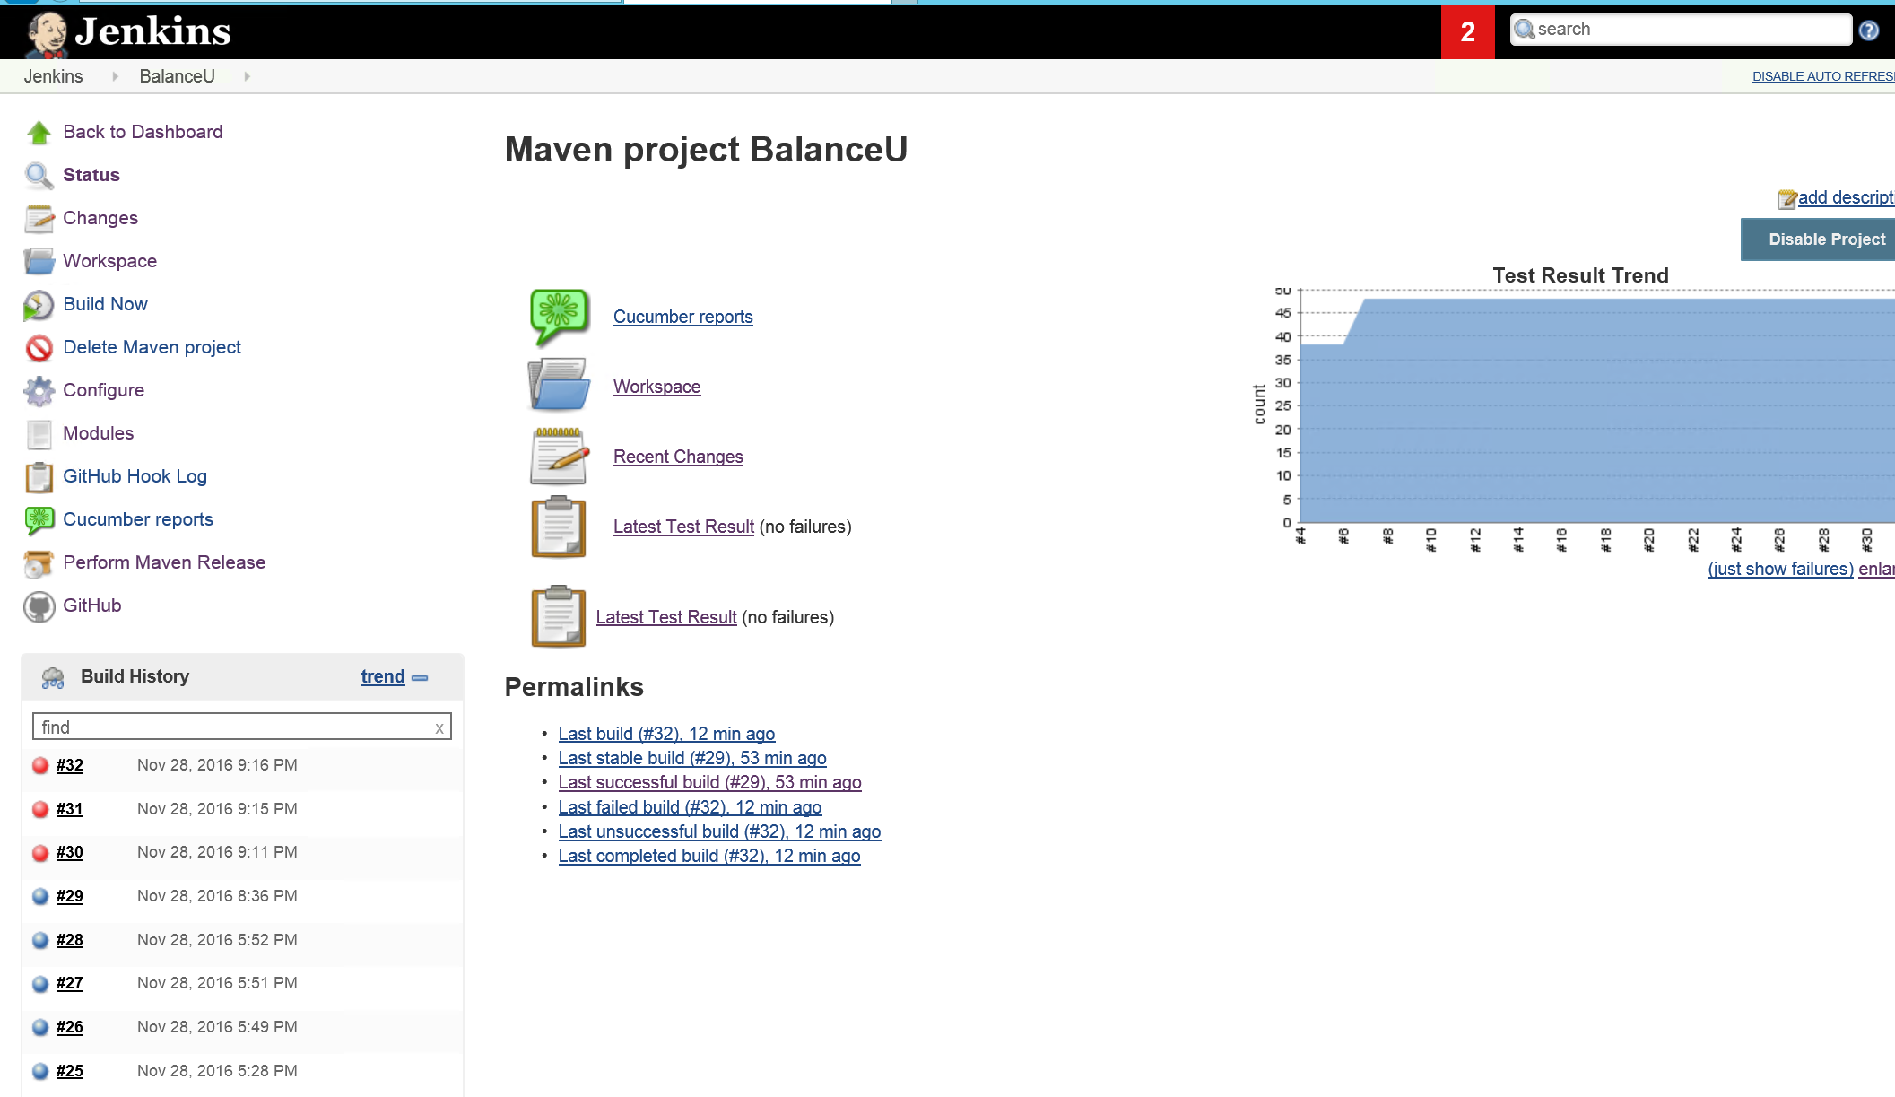

Here is the Jenkins configuration for BalanceU (team #3’s project). Notice “Build when a change is pushed to GitHub” which triggers Jenkins to run a new build automatically upon changes in the GitHub master.

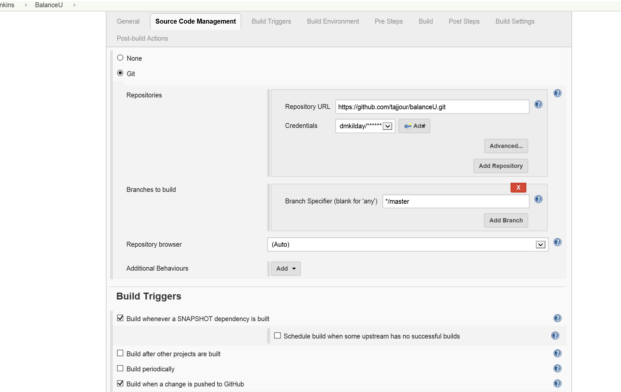

Here are the Unit tests from Junit that are ran every time there is an automated build in Jenkins. Note all tests are passing.

